Coming in October

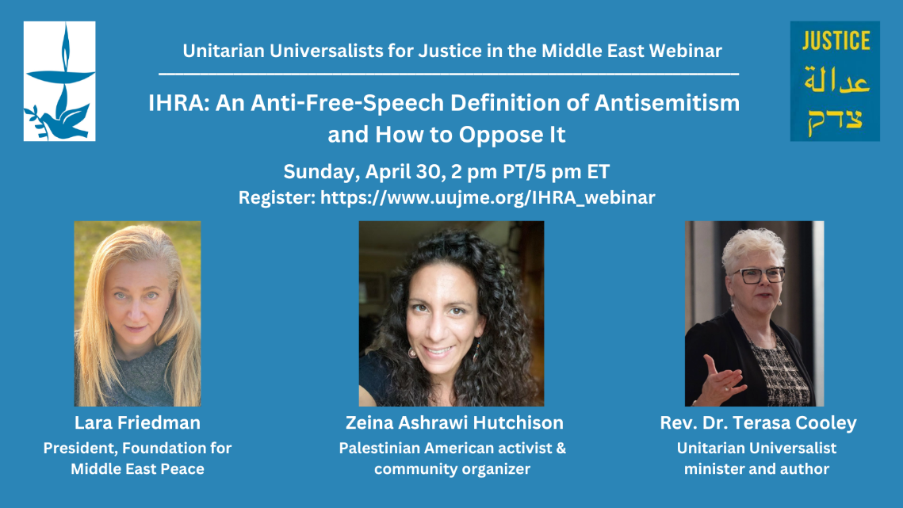

The Peace and Common Security Working group will show a video recording with a live discussion of a webinar presented last April by Unitarian Universalists for Justice in the Middle East. It will be at the Watertown Library, most likely on a Sunday afternoon 2:30-4:30. The event addresses the very problematic attempts to define and codify into law a certain definition of antisemitism. These efforts are at the state, national, and international levels. Known as the IHRA (International Holocaust Remembrance Alliance) definition, it uses examples that conflate criticism of Israeli regimes with antisemitism. Activists for Justice in Palestine are making efforts to expose the truth and danger behind these efforts, that among other ramifications, interfere with countering genuine antisemitism. The definition is mentioned, but not endorsed, in the recent “U.S National Strategy to Counter Anti-Semitism”, from the U.S. Government. The definition has already passed into law in several states to make criticism of Israel illegal. Local activists are monitoring the progress of H1558 in Massachusetts, which basically is a coupyct of other states’ laws.

,