

**A Special Presentation by**

**Veterans for Peace**

**Wednesday, September 20 at 7:00 PM**

*The Vets for Peace describe the Climate Crisis and Militarism Project as part of the world-wide movement to end the climate crisis and promote climate, environmental, racial, and economic justice.  Our emphasis focuses on how US militarism, the single largest institutional source of greenhouse gasses on the planet, fuels the climate crisis.*

The presentation will take place as part of the Monthly Membership meeting of Watertown Citizens for Peace, Justice and the Environment. It will be a zoom meeting at <https://us02web.zoom.us/j/89168192470>. Zoom in to chat at 6:45.

**Join us as we explore the intersection of the climate crisis and militarism.**

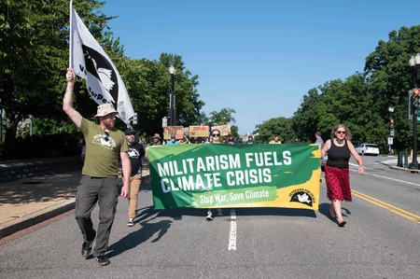

**Program is sponsored by Watertown Citizen’s Peace and Common Security and Watertown Faces Climate Change working groups. We are delighted to have 350 Mass, the Peace and Climate Working Group of Massachusetts Peace Action, and the Smedley Butler Brigade, Chapter 9 of Veterans for Peace as co-sponsors.**